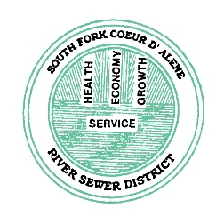In 2014, rate payers voted to approve the requested $18,200,000 levy, which qualified the District for a 40-year bond at 2.5%. It was determined that we needed to raise our rates by $12.85 per month/$38.55 per quarter to pay back this bond. The District wanted to phase in the cost over 4 years to lessen the hardship on our rate payers. The quarterly rate was increase by $9 in March 2015, $9 in March 2016, $9 in March 2017 and $12 in March 2018 (reflected on your current bill). Please contact our office at (208) 753-8041 or visit our website at www.southforksd.com if you have any questions.

